Федеральное государственное автономное образовательное учреждение высшего образования «Национальный исследовательский университет ИТМО»

**Факультет программной инженерии и компьютерной техники**

**Дискретная математика**

Курсовая работа. Часть 1

Выполнил: Герасимов Артём Кириллович

Группа: P3108

Вариант: 6

Преподаватель: Поляков Владимир Иванович

Санкт-Петербург

2021

|  |  |
| --- | --- |
| f = 1 | f = d |
| 0 < |X1X2X4 - X3X5| 2 | |X1X2X4 - X3X5| = 5 |

**Составление таблицы истинности:**

|  |  |  |  |  |  |  |  |  |  |  |  |
| --- | --- | --- | --- | --- | --- | --- | --- | --- | --- | --- | --- |
| **N** | X1 | X2 | X3 | X4 | X5 | X1X2X4 | (X1X2X4)10 | X3X5 | (X3X5)10 | |-| | f |
| **0** | **0** | **0** | **0** | **0** | **0** | **000** | **0** | **00** | **0** | **0** | **0** |
| **1** | **0** | **0** | **0** | **0** | **1** | **000** | **0** | **01** | **1** | **1** | **1** |
| **2** | **0** | **0** | **0** | **1** | **0** | **001** | **1** | **00** | **0** | **1** | **1** |
| **3** | **0** | **0** | **0** | **1** | **1** | **001** | **1** | **01** | **1** | **0** | **0** |
| **4** | **0** | **0** | **1** | **0** | **0** | **000** | **0** | **10** | **2** | **2** | **1** |
| **5** | **0** | **0** | **1** | **0** | **1** | **000** | **0** | **11** | **3** | **3** | **0** |
| **6** | **0** | **0** | **1** | **1** | **0** | **001** | **1** | **10** | **2** | **1** | **1** |
| **7** | **0** | **0** | **1** | **1** | **1** | **001** | **1** | **11** | **3** | **2** | **1** |
| **8** | **0** | **1** | **0** | **0** | **0** | **010** | **2** | **00** | **0** | **2** | **1** |
| **9** | **0** | **1** | **0** | **0** | **1** | **010** | **2** | **01** | **1** | **1** | **1** |
| **10** | **0** | **1** | **0** | **1** | **0** | **011** | **3** | **00** | **0** | **3** | **0** |
| **11** | **0** | **1** | **0** | **1** | **1** | **011** | **3** | **01** | **1** | **2** | **1** |
| **12** | **0** | **1** | **1** | **0** | **0** | **010** | **2** | **10** | **2** | **0** | **0** |
| **13** | **0** | **1** | **1** | **0** | **1** | **010** | **2** | **11** | **3** | **1** | **1** |
| **14** | **0** | **1** | **1** | **1** | **0** | **011** | **3** | **10** | **2** | **1** | **1** |
| **15** | **0** | **1** | **1** | **1** | **1** | **011** | **3** | **11** | **3** | **0** | **0** |
| **16** | **1** | **0** | **0** | **0** | **0** | **100** | **4** | **00** | **0** | **4** | **0** |
| **17** | **1** | **0** | **0** | **0** | **1** | **100** | **4** | **01** | **1** | **3** | **0** |
| **18** | **1** | **0** | **0** | **1** | **0** | **101** | **5** | **00** | **0** | **5** | **d** |
| **19** | **1** | **0** | **0** | **1** | **1** | **101** | **5** | **01** | **1** | **4** | **0** |
| **20** | **1** | **0** | **1** | **0** | **0** | **100** | **4** | **10** | **2** | **2** | **1** |
| **21** | **1** | **0** | **1** | **0** | **1** | **100** | **4** | **11** | **3** | **1** | **1** |
| **22** | **1** | **0** | **1** | **1** | **0** | **101** | **5** | **10** | **2** | **3** | **0** |
| **23** | **1** | **0** | **1** | **1** | **1** | **101** | **5** | **11** | **3** | **2** | **1** |
| **24** | **1** | **1** | **0** | **0** | **0** | **110** | **6** | **00** | **0** | **6** | **0** |
| **25** | **1** | **1** | **0** | **0** | **1** | **110** | **6** | **01** | **1** | **5** | **d** |
| **26** | **1** | **1** | **0** | **1** | **0** | **111** | **7** | **00** | **0** | **7** | **0** |
| **27** | **1** | **1** | **0** | **1** | **1** | **111** | **7** | **01** | **1** | **6** | **0** |
| **28** | **1** | **1** | **1** | **0** | **0** | **110** | **6** | **10** | **2** | **4** | **0** |
| **29** | **1** | **1** | **1** | **0** | **1** | **110** | **6** | **11** | **3** | **3** | **0** |
| **30** | **1** | **1** | **1** | **1** | **0** | **111** | **7** | **10** | **2** | **5** | **d** |
| **31** | **1** | **1** | **1** | **1** | **1** | **111** | **7** | **11** | **3** | **4** | **0** |

**Представление булевой функции в аналитическом виде:**

**КДНФ**: f = x̄1x̄2x̄3x̄4x5 ∨ x̄1x̄2x̄3x4x̄5 ∨ x̄1x̄2x3x̄4x̄5 ∨ x̄1x̄2x3x4x̄5 ∨ x̄1x̄2x3x4x5 ∨ x̄1x2x̄3x̄4x̄5 ∨ x̄1x2x̄3x̄4x5 ∨ x̄1x2x̄3x4x5 ∨ x̄1x2x3x̄4x5 ∨ x̄1x2x3x4x̄5 ∨ x1x̄2x3x̄4x̄5 ∨ x1x̄2x3x̄4x5 ∨ x1x̄2x3x4x5

**ККНФ**: f = (х1 ∨ x2 ∨ x3 ∨ x4 ∨ x5) (х1 ∨ x2 ∨ x3 ∨ x̄4 ∨ x̄5) (х1 ∨ x2 ∨ x̄3 ∨ x4 ∨ x̄5) (х1 ∨ x̄2 ∨ x3 ∨ x̄4 ∨ x5) (х1 ∨ x̄2 ∨ x̄3 ∨ x4 ∨ x5) (х1 ∨ x̄2 ∨ x̄3 ∨ x̄4 ∨ x̄5) (х̄1 ∨ x2 ∨ x3 ∨ x4 ∨ x5) (х̄1 ∨ x2 ∨ x3 ∨ x4 ∨ x̄5) (х̄1 ∨ x2 ∨ x3 ∨ x̄4 ∨ x̄5) (х̄1 ∨ x2 ∨ x̄3 ∨ x̄4 ∨ x5) (х̄1 ∨ x̄2 ∨ x3 ∨ x4 ∨ x5) (х̄1 ∨ x̄2 ∨ x3 ∨ x̄4 ∨ x5) (х̄1 ∨ x̄2 ∨ x3 ∨ x̄4 ∨ x̄5) (х̄1 ∨ x̄2 ∨ x̄3 ∨ x4 ∨ x5) (х̄1 ∨ x̄2 ∨ x̄3 ∨ x4 ∨ x̄5) (х̄1 ∨ x̄2 ∨ x̄3 ∨ x̄4 ∨ x̄5)

**Минимизация функции**

|  |  |  |  |  |  |  |  |
| --- | --- | --- | --- | --- | --- | --- | --- |
| **№** | **K0 U N** | **\*** | **№** | **K1** |  | **№** | **Z(f)** |
| 1 | 00001 | * | 1 | 0x001 | 1-7 | 1 | 0x001 |
| 2 | 00010 | * | 2 | 00x10 | 2-4 | 2 | 00x10 |
| 3 | 00100 | * | 3 | x0010 | 2-11 | 3 | x0010 |
| 4 | 00110 | * | 4 | 001x0 | 3-4 | 4 | 001x0 |
| 5 | 00111 | * | 5 | x0100 | 3-12 | 5 | x0100 |
| 6 | 01000 | * | 6 | 0011x | 4-5 | 6 | 0011x |
| 7 | 01001 | * | 7 | 0x110 | 4-10 | 7 | 0x110 |
| 8 | 01011 | * | 8 | x0111 | 5-14 | 8 | x0111 |
| 9 | 01101 | * | 9 | 0100x | 6-7 | 9 | 0100x |
| 10 | 01110 | * | 10 | 010x1 | 7-8 | 10 | 010x1 |
| 11 | 10010 | * | 11 | 01x01 | 7-9 | 11 | 01x01 |
| 12 | 10100 | * | 12 | x1001 | 7-15 | 12 | x1001 |
| 13 | 10101 | * | 13 | x1110 | 10-16 | 13 | x1110 |
| 14 | 10111 | * | 14 | 1010x | 12-13 | 14 | 1010x |
| 15 | 11001 | * | 15 | 101x1 | 13-14 | 15 | 101x1 |
| 16 | 11110 | * |  |  |  |  |  |

|  |  |  |  |  |  |  |  |  |  |  |  |  |  |  |
| --- | --- | --- | --- | --- | --- | --- | --- | --- | --- | --- | --- | --- | --- | --- |
|  |  | **00001** | **00010** | **00100** | **00110** | **00111** | **01000** | **01001** | **01011** | **01101** | **01110** | **10100** | **10101** | **10111** |
| 0x001 | | (*) |  |  |  |  |  | * |  |  |  |  |  |  |
| 00x10 | |  | * |  | * |  |  |  |  |  |  |  |  |  |
| x0010 | |  | * |  |  |  |  |  |  |  |  |  |  |  |
| 001x0 | |  |  | * | * |  |  |  |  |  |  |  |  |  |
| x0100 | |  |  | * |  |  |  |  |  |  |  | * |  |  |
| 0011x | |  |  |  | * | * |  |  |  |  |  |  |  |  |
| 0x110 | |  |  |  | * |  |  |  |  |  | * |  |  |  |
| x0111 | |  |  |  |  | * |  |  |  |  |  |  |  | * |
| 0100x | |  |  |  |  |  | (*) | * |  |  |  |  |  |  |
| 010x1 | |  |  |  |  |  |  | * | (*) |  |  |  |  |  |
| 01x01 | |  |  |  |  |  |  | * |  | (*) |  |  |  |  |
| x1001 | |  |  |  |  |  |  | * |  |  |  |  |  |  |
| x1110 | |  |  |  |  |  |  |  |  |  | * |  |  |  |
| 1010x | |  |  |  |  |  |  |  |  |  |  | * | * |  |
| 101x1 | |  |  |  |  |  |  |  |  |  |  |  | * | * |

**T = $\left\{\begin{aligned}0x001 \\ 0100x \\ 010x1 \\ 01x01\end{aligned}\right\}$**

|  |  |  |  |  |  |  |  |  |  |
| --- | --- | --- | --- | --- | --- | --- | --- | --- | --- |
|  |  | **00010** | **00100** | **00110** | **00111** | **01110** | **10100** | **10101** | **10111** |
| 00x10 | A | * |  | * |  |  |  |  |  |
| x0010 | B | * |  |  |  |  |  |  |  |
| 001x0 | C |  | * | * |  |  |  |  |  |
| x0100 | D |  | * |  |  |  | * |  |  |
| 0011x | E |  |  | * | * |  |  |  |  |
| 0x110 | F |  |  | * |  | * |  |  |  |
| x0111 | G |  |  |  | * |  |  |  | * |
| x1110 | H |  |  |  |  | * |  |  |  |
| 1010x | I |  |  |  |  |  | * | * |  |
| 101x1 | J |  |  |  |  |  |  | * | * |

Y = (A ∨ B) (C ∨ D) (A ∨ C ∨ E∨ F) (E ∨ G) (F ∨ H) (D ∨ I) (I ∨ J) (J ∨ G) = ADEFJ ∨ ADEHJ ∨ ADFGI ∨ ADFGJ ∨ …

Так как все кубы – 1-кубы, то минимальными покрытиями являются покрытия, состоящие из минимального количества кубов, в данном случае – 5ти

C1 = Sa=36 Sb=45

C2 = Sa=36 Sb=45

C3 = Sa=36 Sb=45

C4 = Sa=36 Sb=45

**Cmin** = Sa=36 Sb=45

**МДНФ**: f = x̄1x̄3x̄4x5 ∨ x̄1x2x̄3x̄4 ∨ x̄1x2x̄3x5 ∨ x̄1x2x̄4x5 ∨ x̄1x̄2x4x̄5 ∨ x̄2x3x̄4x̄5 ∨ x̄1x̄2x3x4 ∨ x̄1x3x4x̄5 ∨ x1x̄2x3x5

|  |  |  |  |  |  |
| --- | --- | --- | --- | --- | --- |
| x1=0 | x2x3 | | | | |
| x4x5 |  | 00 | 01 | 11 | 10 |
| 00 |  | 1 |  | 1 |
| 01 | 1 |  | 1 | 1 |
| 11 |  | 1 |  | 1 |
| 10 | 1 | 1 | 1 |  |

|  |  |  |  |  |  |
| --- | --- | --- | --- | --- | --- |
| x1=1 | x2x3 | | | | |
| x4x5 |  | 00 | 01 | 11 | 10 |
| 00 |  | 1 |  |  |
| 01 |  | 1 |  | d |
| 11 |  | 1 |  |  |
| 10 | d |  | d |  |

**МДНФ**: f = x̄1x̄3x̄4x5 ∨ x̄1x2x̄3x̄4 ∨ x̄1x2x̄3x5 ∨ x̄1x2x̄4x5 ∨ x̄1x̄2x4x̄5 ∨ x̄2x3x̄4x̄5 ∨ x̄1x̄2x3x4∨ x̄1x3x4x̄5 ∨ x1x̄2x3x5

Sa=36 Sb=45

|  |  |  |  |  |  |
| --- | --- | --- | --- | --- | --- |
| x1=0 | x2x3 | | | | |
| x4x5 |  | 00 | 01 | 11 | 10 |
| 00 | 0 |  | 0 |  |
| 01 |  | 0 |  |  |
| 11 | 0 |  | 0 |  |
| 10 |  |  |  | 0 |

|  |  |  |  |  |  |
| --- | --- | --- | --- | --- | --- |
| x1=1 | x2x3 | | | | |
| x4x5 |  | 00 | 01 | 11 | 10 |
| 00 | 0 |  | 0 | 0 |
| 01 | 0 |  | 0 | d |
| 11 | 0 |  | 0 | 0 |
| 10 | d | 0 | d | 0 |

**МКНФ**: f = (x2 ∨ x3 ∨ x4 ∨ x5) (x2 ∨ x3 ∨ x̄4 ∨ x̄5) (х1 ∨ x2 ∨ x̄3 ∨ x4 ∨ x̄5) (x̄2 ∨ x3 ∨ x̄4 ∨ x5) (x̄2 ∨ x̄3 ∨ x4 ∨ x5) (x̄2 ∨ x̄3 ∨ x̄4 ∨ x̄5) (х̄1 ∨ x3) (х̄1 ∨ x̄4 ∨ x5) (х̄1 ∨ x̄2)

Sa=32 Sb=41

**Факторное преобразование для МДНФ:**

x̄1x̄3x̄4x5 ∨ x̄1x2x̄3x̄4 ∨ x̄1x2x̄3x5 ∨ x̄1x2x̄4x5 V x̄1x̄2x4x̄5 ∨ x̄2x3x̄4x̄5 ∨ x̄1x̄2x3x4 ∨ x̄1x3x4x̄5 ∨ x1x̄2x3x5 =SQ = 45

= x̄1x̄3x̄4 (x5 ∨ x2) ∨ x̄1x2x5 (x̄3 ∨ x̄4)∨ x̄1x̄2x4x̄5 ∨ x̄2x3x̄4x̄5 ∨ x̄1x3x4 (x̄2 ∨ x̄5)∨ x1x̄2x3x5 =   
SQ = 36

**Факторное преобразование для МКНФ:**

(x2 ∨ x3 ∨ x4 ∨ x5) (x2 ∨ x3 ∨ x̄4 ∨ x̄5) (х1 ∨ x2 ∨ x̄3 ∨ x4 ∨ x̄5) (x̄2 ∨ x3 ∨ x̄4 ∨ x5) (x̄2 ∨ x̄3 ∨ x4 ∨ x5) (x̄2 ∨ x̄3 ∨ x̄4 ∨ x̄5) (х̄1 ∨ x3) (х̄1 ∨ x̄4 ∨ x5) (х̄1 ∨ x̄2) =SQ = 41

= (x2 ∨ x3 ∨ x̄5x4 ∨ x5x̄4) (х1 ∨ x2 ∨ x̄3 ∨ x4 ∨ x̄5) (x̄2 ∨ x3 ∨ x̄4 ∨ x5) (x̄2 ∨ x̄3 ∨ x̄5x4 ∨ x5x̄4) (х̄1 ∨ (x̄4 ∨ x5) x̄2x3)

SQ = 37

= (x2 ∨ x3 ∨ φ) (х1 ∨ x2 ∨ x̄3 ∨ x4 ∨ x̄5) (x̄2 ∨ x3 ∨ x̄4 ∨ x5) (x̄2 ∨ x̄3 ∨ φ) (х̄1 ∨ (x̄4 ∨ x5)x̄2x3)

SQ = 34

φ = x̄5x4 ∨ x5x̄4

**Булев базис**

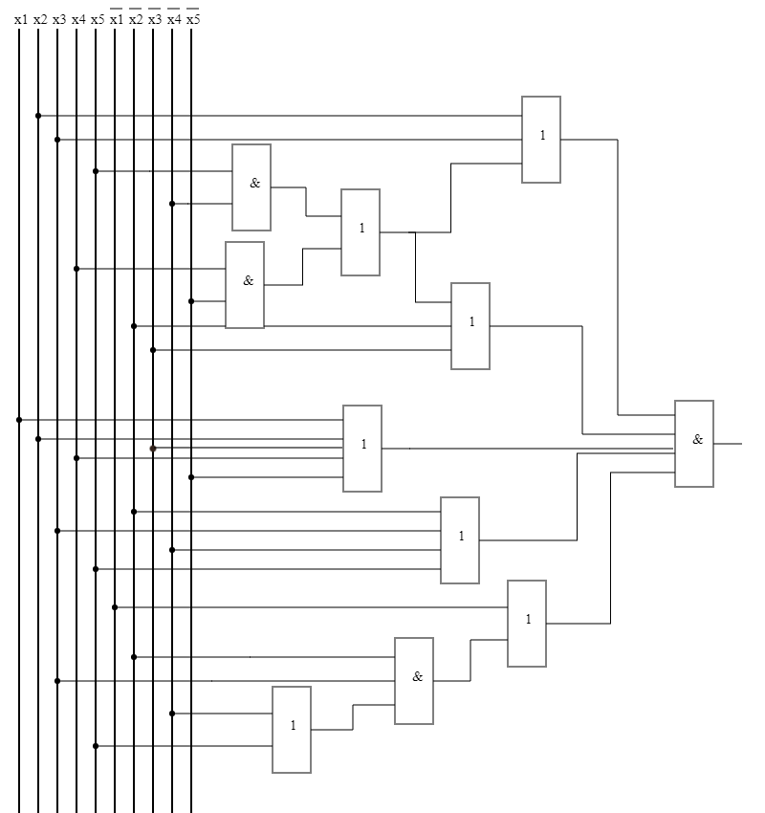

SQ=34 τ=4t

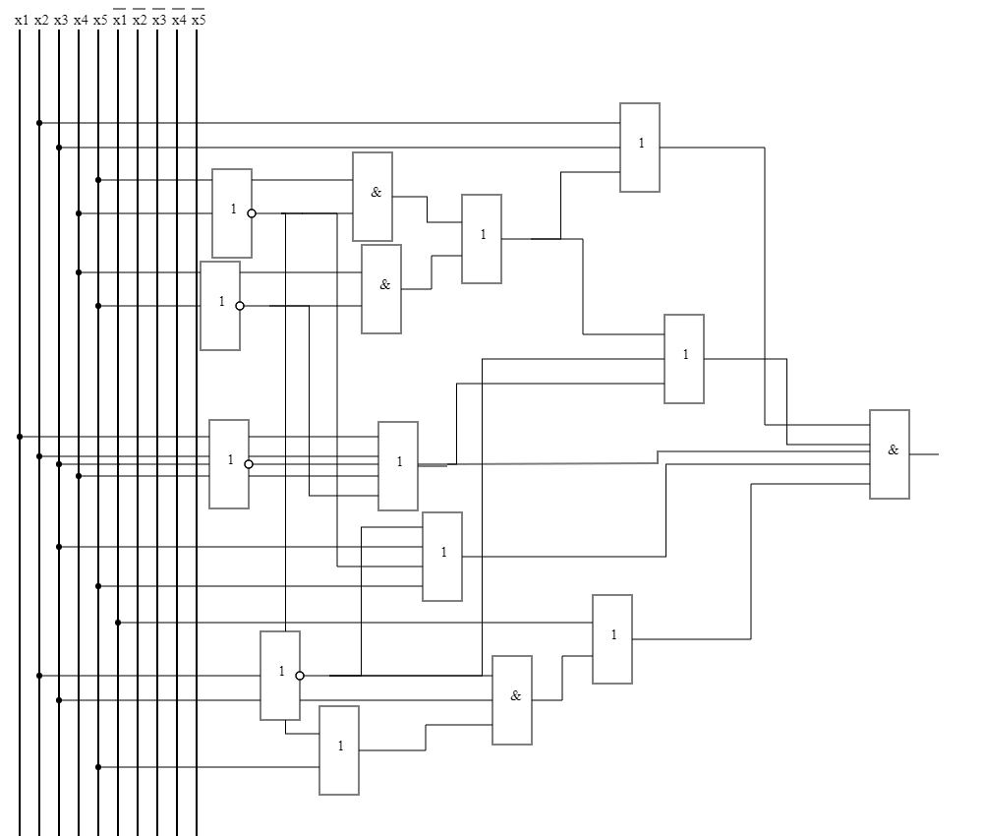**Схема с однофазными входами**

SQ=39 τ=5t

**Базис или-не**

x̄1x̄3x̄4 (x5 ∨ x2) ∨ x̄1x2x5 (x̄3 ∨ x̄4)∨ x̄1x̄2x4x̄5 ∨ x̄2x3x̄4x̄5 ∨ x̄1x3x4 (x̄2 ∨ x̄5) ∨ x1x̄2x3x5 =

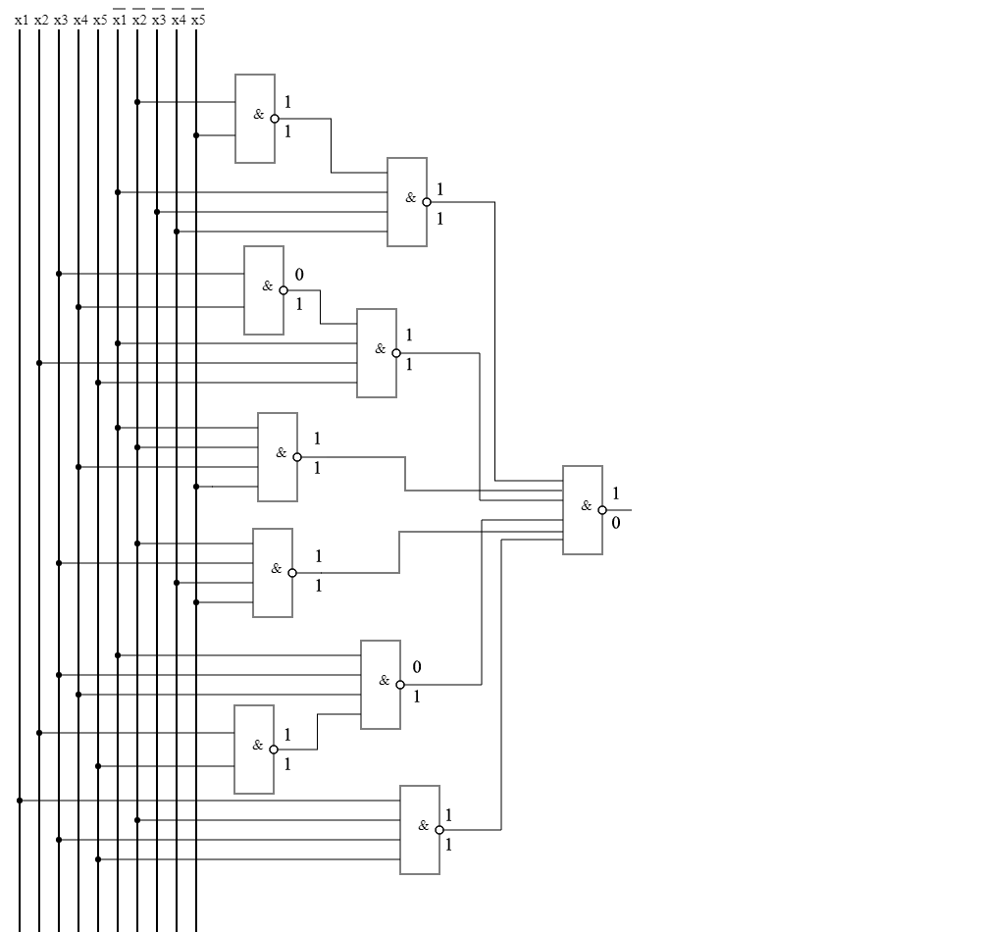(x̄1 | x̄3 |x̄4 | (x̄2 | x̄5)) | (x̄1 | x2 | x5 | (x3 | x4)) | (x̄1 | x̄2 | x4 | x̄5) | (x̄2 | x3 | x̄4 | x̄5) | (x̄1 |x3 |x4 (x5 | x2)) | (x1 | x̄2 | x3 | x5)

SQ=36 τ=3t

Анализ схемы:

F(01110) = 1

F(10001) = 0